**Course: Advance Bio Informatics**

**Module Title: Consensus Tree in phylogenetics**

**Module No: 65**

The representative summary of a set of source trees. Consensus trees can only be the most optimal tree when it is identical to one of the optimal source trees. Consensus trees have lost the information about what trees went into them, so reconstructing character evolution (mapping) and use of tree length on them should be avoided, or maybe done with extreme caution.

taxon000000  
taxon1 10100

taxon2 01011

taxon3 01011

taxon4 11110

1. **Strict consensus:**  A frequency based method. Only monophyletic groups found in all source trees are found in the resultant tree. The tree excludes a subset of all possible trees and conversely includes a subset of possible trees, whether or not they are part of the source set. In some sense the most conservative consensus. However, consider the bush.

e.g. (A(B(CD))) + (A(C(BD))) = (A (BCD)) but this also implies (A(D(BC)))

1. **Semistrict Consensus:**  A frequency based method. (aka, Bremer trees or combinable components) - Only monophyletic groups found in at least one of the source trees and compatible (not in conflict) with all other source trees are found in the resultant tree, i.e. if a clade is never contradicted, but not always supported, then it is still included in this compromise tree.
2. **Majority-rule:** Again, a frequency based method. Shows groups that appear on pre-specified percentage of source trees, usually >50%. Used for summary of searches where plurality is important. Can result in a tree that contains two groups that are simultaneously found in only one of the source trees (minimum to make majority =0.5T+ 1).

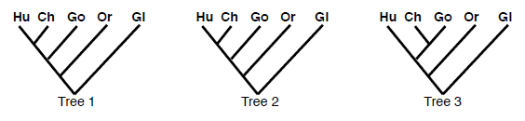

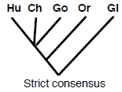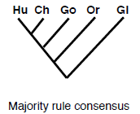

**Majority Rule Consensus Tree**

**Conclusion**

Un-rooted Tree with weights showing relation between nodes

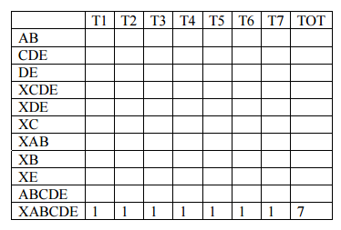

1. **Greedy consensus.** Frequency based method. Groups ordered by frequency like in Majority-rule, then added in to the consensus tree as long as they are compatible. How will ties in frequency change the results?
2. **Adams –** An intersection method. Inconsistently placed taxa are moved to the first node that summarizes the possible topologies. Groups can appear in Adams consensus that are not found in any source tree. Adams trees have no biological or phylogenetic interpretation. They do point to “wildcard” taxa. Those taxa may be experimentally removed from the matrix and the resulting analysis compared to when they are included.
3. **Matrix representation with parsimony (MRP).** A recoding consensus method that can be used for trees with different sets of taxa. Both topology and frequency are important. Unrooted source trees

((a b c)(d e f))

((a b c)(d e f))

((a b c)(d e f))

((a b c)(d e f))

((a d e)(b c f))

((b d e)(a c f))

((c d e)(a b f))

taxon0 00000000

taxonA 10100101

taxonB 10011001

taxonC 10010110

taxonD 01101010

taxonE 01101010

taxonF 01010101

((de) (abc)f)